Capstone Project 2 - Milestone Report

**Understanding the Problem Statement:**

It is very difficult to predict the way stock market behaves. One good way to look at it is analyzing the historical data associated and predict future trends. But there are so many other factors that impact a stock price - market sentiments, boards financial decisions, geographical locations and nowadays social media interaction via Twitter etc. This means that there are no consistent patterns in the data that allow you to model stock prices over time near-perfectly. However, lets not loose our hopes and concentrate on what machine learning can do here to model the data, so that the predictions we make correlate with the actual behavior of the data.

Broadly, stock market analysis is divided into two parts – Fundamental Analysis and Technical Analysis.

Fundamental Analysis involves analyzing the company’s future profitability on the basis of its current business environment and financial performance. Technical Analysis, on the other hand, includes reading the charts and using statistical figures to identify the trends in the stock market. We will focus here on the technical analysis part and use **Amazon stock data** from macrotrends.com to dive in!

**Client:**

The prospective client would be any one interested in making money out of stock market. The analysis and predictions are done on amazon dataset, however, it can be used on any other stock whose historical data is available.

**Data Set:**

|  |  |
| --- | --- |
| **Variable name** | **Variable description** |
| date | Date on which Amazon trades were done |
| open | price of the stock at market open (this is NYSE data so  all in USD) |
| high | Highest price reached in the day |
| close | Closed price at the end of the day |
| low | Lowest price reached in the day |
| volume | Number of shares traded |

**Data Wrangling / Cleaning:**

**There were different data wrangling techniques that I wanted to use, however, the data that I downloaded from microtrends.com seems to be pretty much clean in all aspects based on initial observation. Below is a snapshot of some techniques used:**

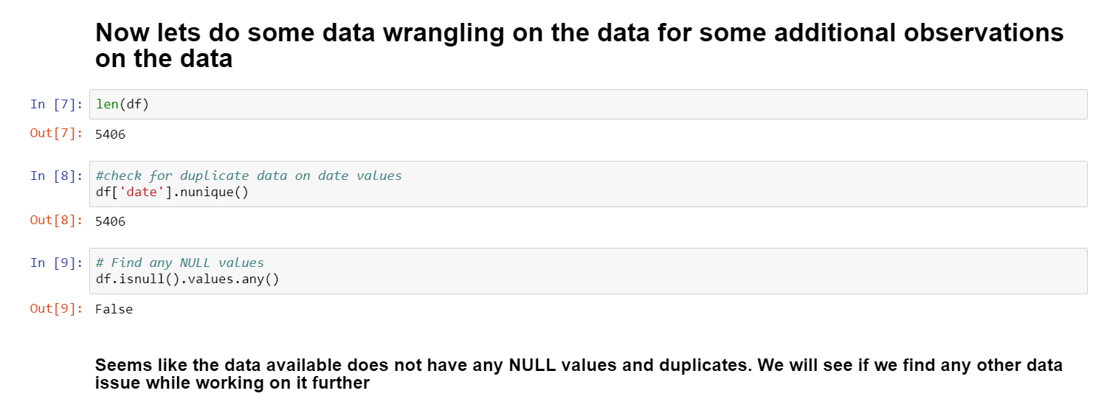

**Other potential data sets:**

There are other data sets that can also be used for this activity.

* https://www.kaggle.com/janiobachmann/s-p-500-simple-forecasting-with-prophet/data

Also, apart from Amazon you can find the historical stock data for a lot of different companies like Apple, Uber, Microsoft, etc that can be used for forecasting purpose.

**Initial findings:**

I downloaded the Amazon data and did some initial analysis and forecasting using Moving Average Method. They can be found at:-

<https://github.com/anshuldikshit81/Capstone-2/blob/master/Milestone-InitialAnalysis.ipynb>